

Student Name | Swapnil Birajdar
SRN No | 31231287
Roll No | 41
Program | B.Tech AIDS
Year | Third Year
Division | A
Subject | Computer Network Laboratory (BTECCE21506)
Assignment No | 9

Assignment Number - 09

Title : Socket Programming for TCP Client and TCP Server.

Problem Statement : Write a C /C++ / Java / Python socket program for TCP where TCP Client communicate with TCP server.

Theory :

A network socket is an endpoint of an inter-process communication flow across a computer network. Today, most communication between computers is based on the Internet Protocol; therefore most network sockets are Internet sockets.
A socket API is an application programming interface (API), usually provided by the operating system, that allows application programs to control and use network sockets. Internet socket APIs are usually based on the Berkeley sockets standard.
A socket address is the combination of an IP address and a port number, much like one end of a telephone connection is the combination of a phone number and a particular extension. Based on this address, internet sockets deliver incoming data packets to the appropriate application process or thread.
Procedure in Client-Server Communication
There are some procedures that we have to follow to establish client-server communication. These are as follows.
Socket: With the help of a socket, we can create a new communication.
Bind: With the help of this we can, we can attach the local address with the socket.
Listen: With this help; we can accept the connection.
Accept: With this help; we can block the incoming connection until the request arrives.
Connect: With this help; we can attempt to establish the connection.
Send: With the help of this; we can send the data over the network.
Receive: With this help; we can receive the data over the network.
Close: With the help of this, we can release the connection from the network.

A connection is a type of relationship between two machines where the two software are known about each other. These two software know how to establish a connection with each other; in other words, we can say that this two software know how to send the bits over the network. A connection of the socket means the two machines should know all the information between each other, like the phone number, IP address, and the TCP port.

A socket is a type of object which is similar to the file that allows the program to accept the incoming connection and allow them to send or receive the incoming connection. Also, it is a type of resource assigned to the server's process.

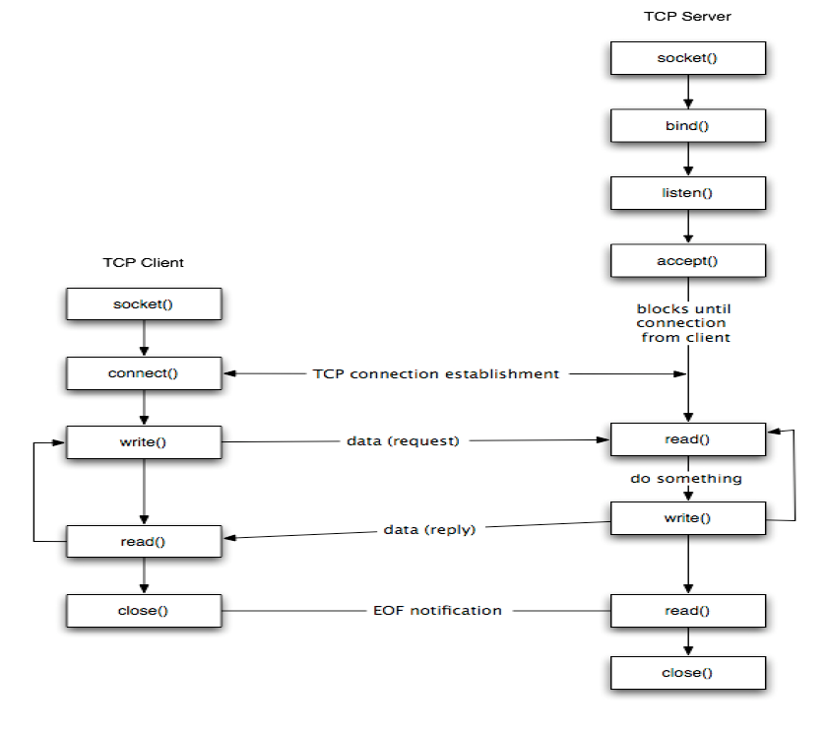

Figure : TCP Client Server Communication

Program :

//TCP SERVER PROGRAM
#include<unistd.h>
#include<stdio.h>
#include<sys/types.h>
#include<sys/socket.h>
#include<netinet/in.h>
#include<arpa/inet.h>
#include<string.h>
#include<stdlib.h>
#include<pthread.h>
#define MAX 30
int ssfd;
int ccfd,res;
int serverlen,clientlen;
struct sockaddr_in serveraddr;
struct sockaddr_in clientaddr;
char result[MAX];
float addition (float a, float b);
typedef struct message
{
float input[2];
float output;
int ch;
}message;

void main()
{
int msgLen;
char *ch;
ssfd=socket(AF_INET,SOCK_STREAM,0);
message *msg;
message *reply;
msg=(message*)malloc(sizeof(message));
reply=(message*)malloc(sizeof(message));

printf("\nWaiting for connection \n SSFD Value:%d",ssfd);
msgLen=sizeof(message);
serveraddr.sin_family=AF_INET;
serveraddr.sin_addr.s_addr=inet_addr("127.0.0.1");
serveraddr.sin_port=9734;
serverlen=sizeof(serveraddr);
bind(ssfd,(struct sockaddr*)&serveraddr,serverlen);
printf("\nConnected to socket");
listen(ssfd,5);
ccfd=accept(ssfd,(struct sockaddr*)&clientaddr,&clientlen);
printf("\nConnection accepted successfully \n");
while(1)
{
read(ccfd,reply,msgLen);
switch(reply->ch)
{
case 1:
printf("First Value is %f \n",reply->input[0]);
printf("Second Value is %f \n",reply->input[1]);
printf("Addition is %f",addition((float)reply->input[0], (float)reply->input[1]));
fflush(stdout);
reply->output = addition((float)reply->input[0], (float)reply->input[1]) ;
write(ccfd,reply,msgLen);
break;
}

}
}
float addition (float a, float b)
{
float result;
result = a + b ;
return result;
}

//TCPCLIENT PROGRAM

#include<unistd.h>
#include<stdio.h>
#include<sys/types.h>
#include<sys/socket.h>
#include<netinet/in.h>
#include<arpa/inet.h>
#include<string.h>
#include<stdlib.h>
#define MAX 30

typedef struct message
{
float input[2];
float output;
int ch;
}message;

void main()
{
int ssfd;
int len;
int msgLen;
struct sockaddr_in address;
int result;
FILE *fp;
char ch='A';
message *msg;
message *reply;
msg=(message*)malloc(sizeof(message));
reply=(message*)malloc(sizeof(message));
msgLen=sizeof(message);
ssfd=socket(AF_INET,SOCK_STREAM,0);
address.sin_family=AF_INET;
address.sin_addr.s_addr=inet_addr("127.0.0.1");
address.sin_port=9734;
len=sizeof(address);
result=connect(ssfd,(struct sockaddr*)&address,len);
if(result==-1){
perror("Server not found");
printf("\nError Result:%d",result);
}
printf("\nConnection successful");
do{
printf("\n\nSELECT Appropriate Option:\n");
printf("\n1.\tAddition");
printf("\n2.\tDisconnect And Exit");
scanf("%d",&msg->ch);
printf("Your Choice:%d",msg->ch);
switch(msg->ch)
{
case 1:
printf("\nEnter any First value:");
scanf("%f",&msg->input[0]);
printf("\nEnter any Second value:");
scanf("%f",&msg->input[1]);
write(ssfd,msg,msgLen);
read(ssfd,reply,msgLen);
printf("Output from server:%f",reply->output);
break;

default:
printf("Invalid Choice....Select Another");
break;
}
}while(msg->ch!=2);
close(ssfd);
}

/************************************
TCP SERVER TERMINAL
*************************************/
arnavi@arnavi-Inspiron-N5110:~/finalTCP$ gcc server.c
arnavi@arnavi-Inspiron-N5110:~/finalTCP$ ./a.out
Waiting for connection
SSFD Value:3
Connected to socket
Connection accepted successfully
First Value is 12.300000
Second Value is 13.200000
Addition is 25.500000
First Value is 12.000000
Second Value is 22.000000
Addition is 34.000000

/************************************
TCP CLIENT TERMINAL
*************************************/
arnavi@arnavi-Inspiron-N5110:~/finalTCP$ gcc client.c
arnavi@arnavi-Inspiron-N5110:~/finalTCP$ ./a.out
Connection successful
SELECT Appropriate Option:
1. Addition
2. Disconnect And Exit1
Your Choice:1
Enter any First value:12.3
Enter any Second value:13.2
Output from server:25.500000
SELECT Appropriate Option:
1. Addition
2. Disconnect And Exit1
Your Choice:1
Enter any First value:12

Enter any Second value:22
Output from server:34.000000
SELECT Appropriate Option:
1. Addition
2. Disconnect And Exit2
Your Choice:2

Conclusion : <<Write Conclusion in your own words. Write about what you learn from OSPF protocol implementation >>

